**Implementation of AI Resources Into The Design of a Database**

**AI Used For this Task: ChatGPT.**

Design of the E/R Diagram:

The picture aboves depicts the original design of our library’s database that was made by the human hand. As we can see, it has various multivalued attributes and also some language mistakes.

After asking ChatGPT to analyze this chart, it was able to detect not only the written mistakes but also it did suggest some changes to improve the qualitiy of this diagram. Some of these suggestions are listed here below:

* Removing the “author” attribute from the “book” entity since it can already be referenced from the “author” entity involved in the “writes” relationship.
* Correcting the name of the attribute “Telefonos” to “Phones” since the first one is in Spanish.
* Normalizing the multivalued attributes by creating a separate entity for them.

Nevertheless, despite its ability to create picturesque images, ChatGPT wasn’t able to pour all of its ideas and suggestions into a well-formed diagram. Therefore, even though one could keep on insisting that it corrects these inaccuracies in language, the schemes would still be brimming with flaws. Examples of these graphs are presented next:

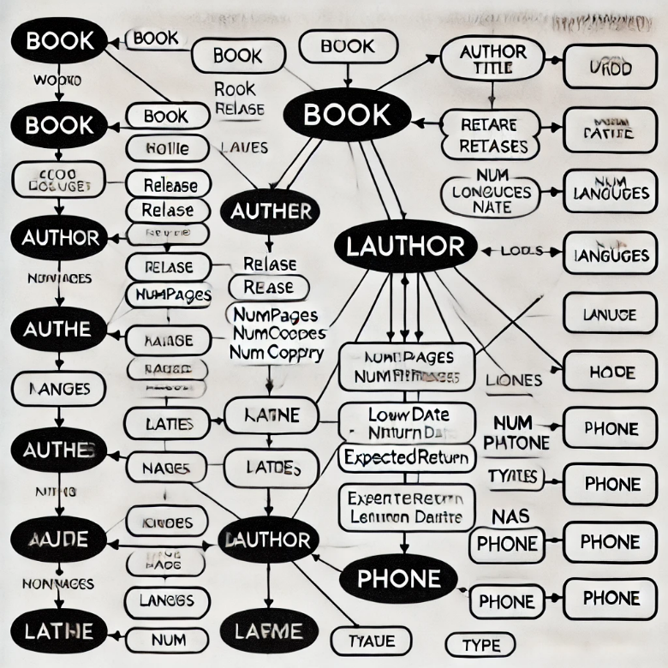

After applying the recommendations given by the AI driven individual, my E/D diagram looks like this: